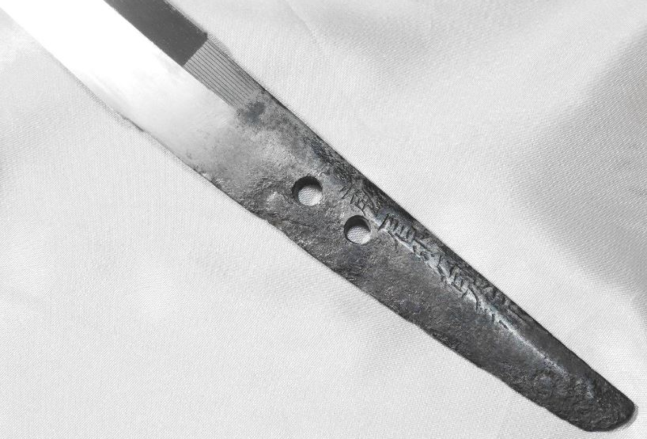 | Fujiwara Sadayuki | wakizashi | 2017-02-24 17 :44

